**Task 1:** Implement paging and segmentation code in C.

**Code:**

#include <stdio.h>

void paging(int logical_address, int page_size, int page_table_size, int num_pages) {

int page_table[page_table_size];

for (int i = 0; i < page_table_size; i++) {

page_table[i] = i; // Map logical page number to physical frame number

}

int page_number = logical_address / page_size;

int offset = logical_address % page_size;

if (page_number >= 0 && page_number < num_pages) {

int physical_frame = page_table[page_number];

int physical_address = physical_frame * page_size + offset;

printf("Paging: Physical address: %d\n", physical_address);

} else {

printf("Invalid page number\n");}}

void segmentation(int logical_address, int segment_size, int num_segments) {

int segment_table[num_segments];

for (int i = 0; i < num_segments; i++) {

segment_table[i] = i * segment_size;

}

int segment_number = logical_address / segment_size;

int offset = logical_address % segment_size;

if (segment_number >= 0 && segment_number < num_segments) {

int base_address = segment_table[segment_number];

int physical_address = base_address + offset;

printf("Segmentation: Physical address: %d\n", physical_address);

} else {

printf("Invalid segment number\n");

}}

int main() {

int logical_address;

int page_size, page_table_size, num_pages;

int segment_size, num_segments;

printf("Enter logical address: ");

scanf("%d", &logical_address);

printf("Enter page size: ");

scanf("%d", &page_size);

printf("Enter page table size: ");

scanf("%d", &page_table_size);

printf("Enter number of pages: ");

scanf("%d", &num_pages);

printf("Enter segment size: ");

scanf("%d", &segment_size);

printf("Enter number of segments: ");

scanf("%d", &num_segments);

paging(logical_address, page_size, page_table_size, num_pages);

segmentation(logical_address, segment_size, num_segments);

return 0;}

**Output:**

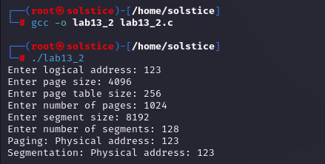

**Task2:** Implement the FIFO and LRU policies described above in C language.

**Code:**

**FIFO:**

#include <stdio.h>

#define MAX_FRAMES 10

#define MAX_REF_STRING 100

void fifo(int ref_string[], int ref_length, int num_frames) {

int frames[MAX_FRAMES] = {-1}; int page_faults = 0;

int counter = 0;

printf("FIFO Page Replacement Policy implementation\n");

for (int i = 0; i < ref_length; ++i) {

int page_number = ref_string[i];

int page_found = 0;

for (int j = 0; j < num_frames; ++j) {

if (frames[j] == page_number) {

page_found = 1;

break; }}

if (!page_found) {

if (counter == num_frames) {

counter = 0;

}

frames[counter] = page_number;

counter++;

page_faults++;

}

printf("Frames: ");

for (int j = 0; j < num_frames; ++j) {

if (frames[j] != -1)

printf("%d ", frames[j]);

else

printf("- ");

}

printf("\n");

}

printf("\nTotal Page Faults = %d\n", page_faults);

}

int main() {

int ref_string[MAX_REF_STRING];

int ref_length, num_frames;

printf("Enter length of reference string: ");

scanf("%d", &ref_length);

printf("Enter reference string: ");

for (int i = 0; i < ref_length; ++i) {

scanf("%d", &ref_string[i]);

}

printf("Enter number of frames: ");

scanf("%d", &num_frames);

fifo(ref_string, ref_length, num_frames);

return 0;

}

**FIFO:**

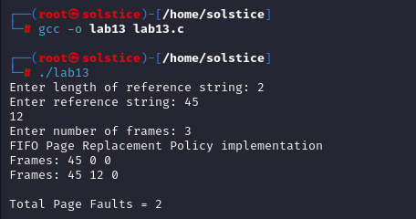

**LRU Code:**

#include <stdio.h>

#define MAX_FRAMES 10

#define MAX_REF_STRING 100

void lru(int ref_string[], int ref_length, int num_frames) {

int frames[MAX_FRAMES] = {-1}; int page_faults = 0;

int counter = 0;

printf("LRU Page Replacement Policy implementation\n");

for (int i = 0; i < ref_length; ++i) {

int page_number = ref_string[i];

int page_found = 0;

for (int j = 0; j < num_frames; ++j) {

if (frames[j] == page_number) {

page_found = 1;

break;}}

if (!page_found) {

if (counter == num_frames) {

counter = 0; // Reset counter if it exceeds the number of frames

}

frames[counter] = page_number;

counter++;

page_faults++;}

printf("Frames: ");

for (int j = 0; j < num_frames; ++j) {

if (frames[j] != -1)

printf("%d ", frames[j]);

else

printf("- ");

}

printf("\n");

}

printf("\nTotal Page Faults = %d\n", page_faults);

}

int main() {

int ref_string[MAX_REF_STRING];

int ref_length, num_frames;

printf("Enter length of reference string: ");

scanf("%d", &ref_length);

printf("Enter reference string: ");

for (int i = 0; i < ref_length; ++i) {

scanf("%d", &ref_string[i]);

}

printf("Enter number of frames: ");

scanf("%d", &num_frames);

lru(ref_string, ref_length, num_frames);

return 0;

}

**LRU:**

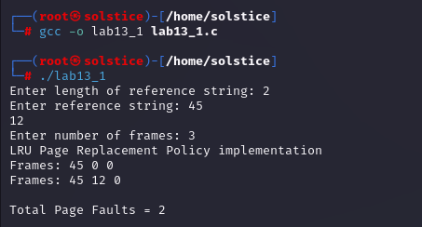

**Task 3:** Execute both programs for the same set of reference strings. What difference did you observe? Comment.

**Answer:**

Executing both programs for the same set of reference strings allows us to compare the performance of different memory management schemes and page replacement policies.

By inputting the same reference strings into both the paging/segmentation code and the FIFO/LRU code, we can observe how each scheme handles page faults and memory access patterns.

**Difference:**

* Paging and segmentation focus on how memory is divided and mapped, while FIFO and LRU focus on how pages are replaced in memory.
* Paging and segmentation may result in different physical addresses for the same logical address, depending on their mapping strategies.
* FIFO and LRU may result in different numbers of page faults, depending on their replacement policies.